UMBRELLO
NAME: R. VIDULA COURSE CODE: CSA1013
REG NO: 192511270 COURSE NAME: SOFTWARE
ENGINEERING
EXP:01-Online Food Delivery System – UML Diagrams

AIM
To design UML Class, Use Case, and Activity Diagrams for an Online Food Delivery System..

UML DIAGRAMS 1. CLASS DIAGRAM

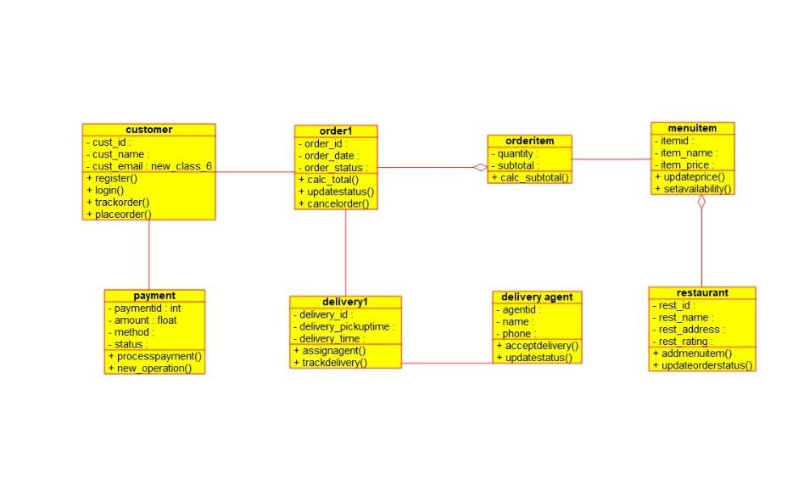

2. USE CASE DIAGRAM

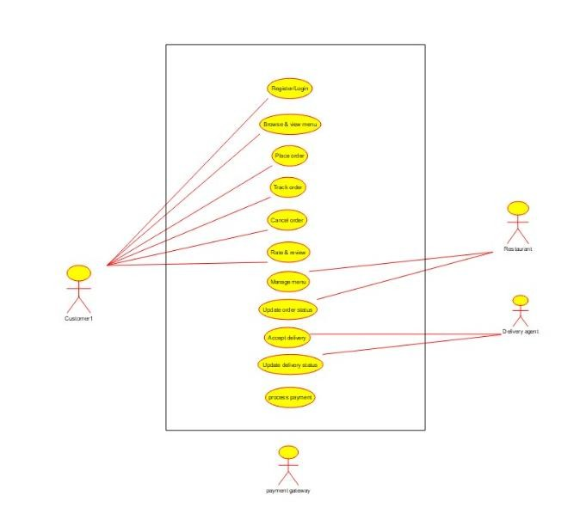

3. ACTIVITY DIAGRAM

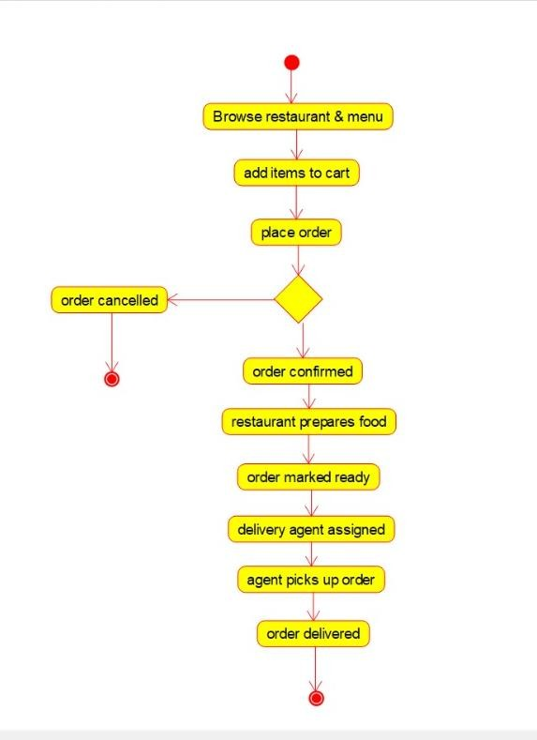

RESULT
The Class, Use Case, and Activity Diagrams were successfully designed to represent the system's structure and workflow.

EXP: 02 - Online Security Management System – UML Diagrams

AIM
To design UML Class, Use Case, and Activity Diagrams for an Online Security Management System.
WORKFLOW

1.CLASS DIAGRAM

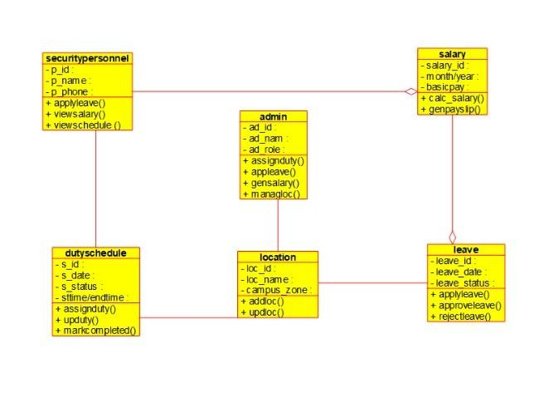

2. ACTIVITY DIAGRAM

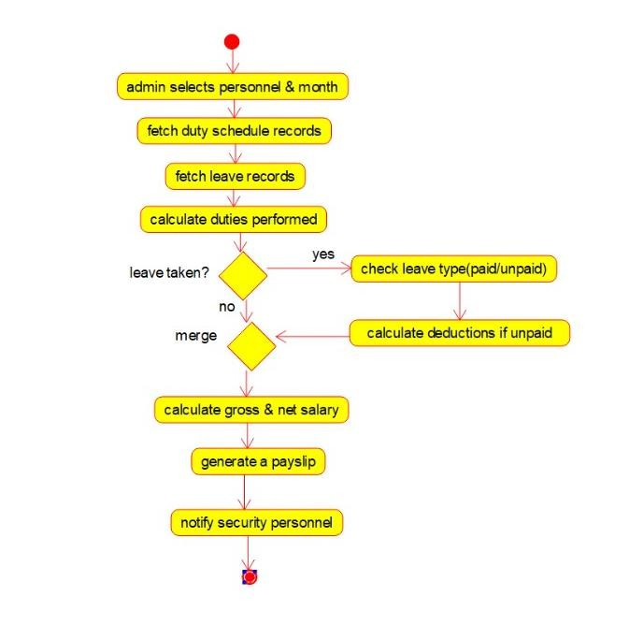

3.USECASE DIAGRAM

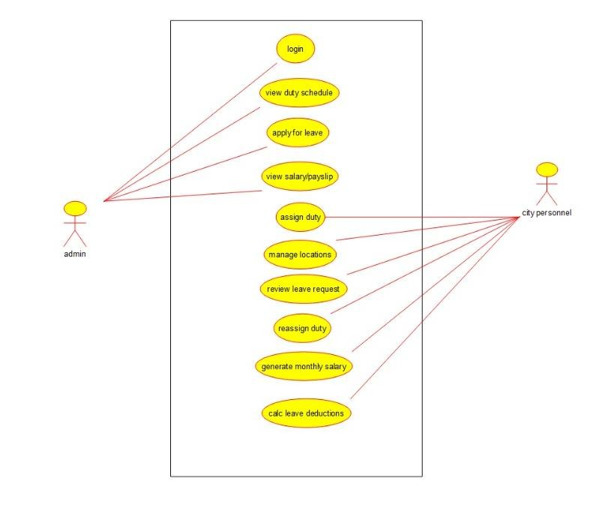

RESULT
The Class, Use Case, and Activity Diagrams were successfully designed to represent duty allocation, leave management, and salary calculation.

